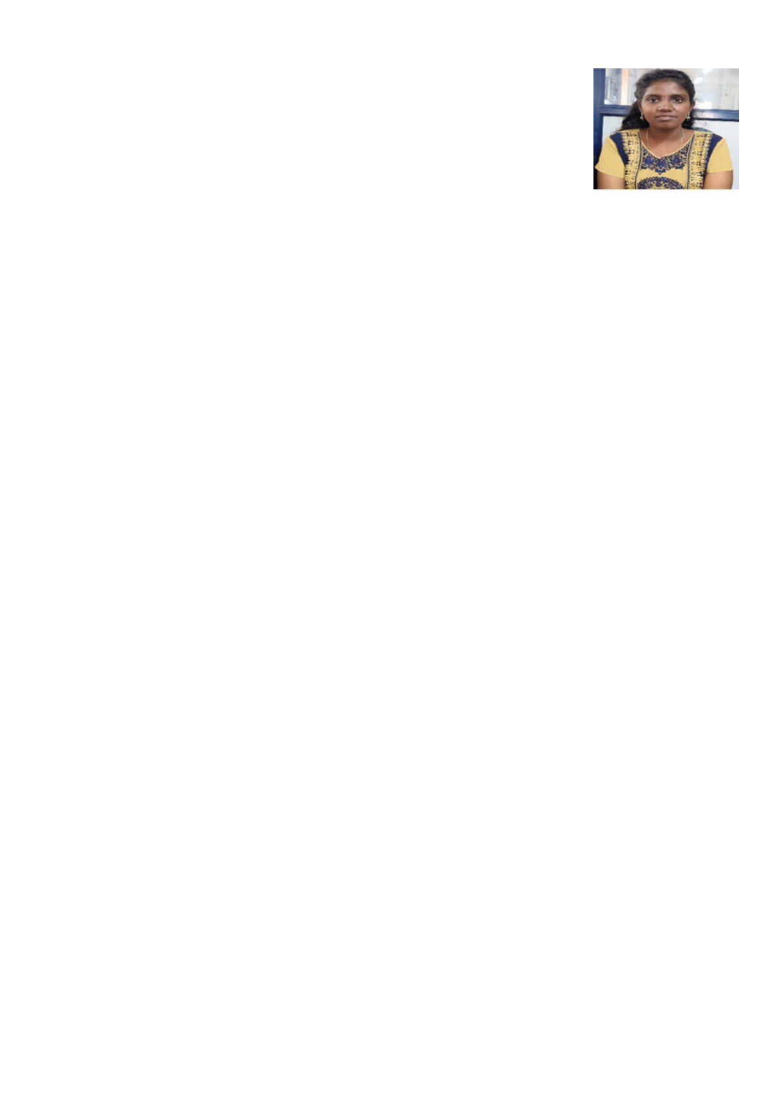

**R. RAJA SRI**

Email ID **:**rajaramesh3110@gmail.comMobile number **:**

6369987920Address  **:** 143, poomalravouthar kovil theru, Navamani colony, kizhavasal, Avusahibthottakm,Thanjavur, Thanjavur, TamilNadu,

613001.Objective **:**

To learn and grow in a professional organization by activity participation a team and aim to synchroise personal goal with organization.

Educational profile**:**

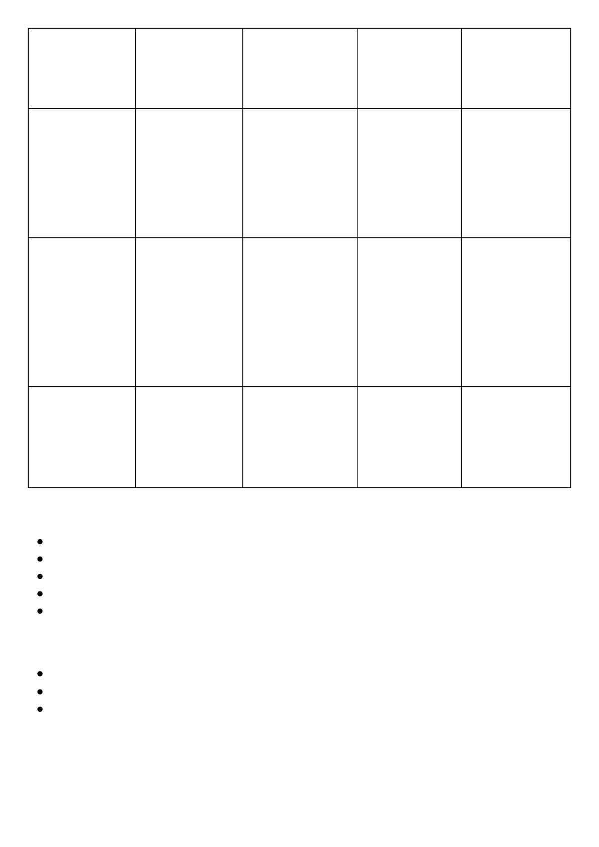

|  |  |  |  |  |
| --- | --- | --- | --- | --- |
| Name of the course | Name of the institute | Board/  university | Year of  passing | percentage% |
| B.Sc. | Rajah Serfoji Government College | Bharadhidhasan  University | 2023-2026 | 85% |
| 12th(HSC) | **G**overnmentGir ls higher  secondary  school | State board | 2022-2023 | 80% |
| 10th(SSLC) | Government Girls Higher Secondary  school | State board | 2020-2021 | 75% |

Relevant Skills:

Effective communication skills.

Inter personal relationship.

Positive attitude worker.

Optimistic of realistic.

Ability to work under pressure& relate well with people.

Technical skills**:**

Object Oriented Programming using Python Edunet-SkillsBuild Orientation   
TNSDC-FEWD&Cloud

Personal profile**:**

Father Name : Ramesh KumarMother Name : Jaya deviDate of Brith : 31/10/2005Gender :   
FemaleReligion : HinduNationality : IndianBlood

|  |  |  |  |  |
| --- | --- | --- | --- | --- |
| k | li h | il | f | b |



: O+veLanguages known : English, TamilReference number : 6369987920 , 9361244329

Declaration**:** I here declare that the details finished about are true to the best of my knowledge.

Date : 08-03-2025signatureplace : Thanjavur

Rajasri